*How to work on Emergency request(MAINFRAME PART)*

1. Login to RTC and complete the staging (Promotion and deploy same as that of Release Deployment)
2. After completion of staging activity from RTC login to PComm
3. How to login to TSO –
   1. Open PComm from citrix
   2. Enter RACF user ID and password and press enter

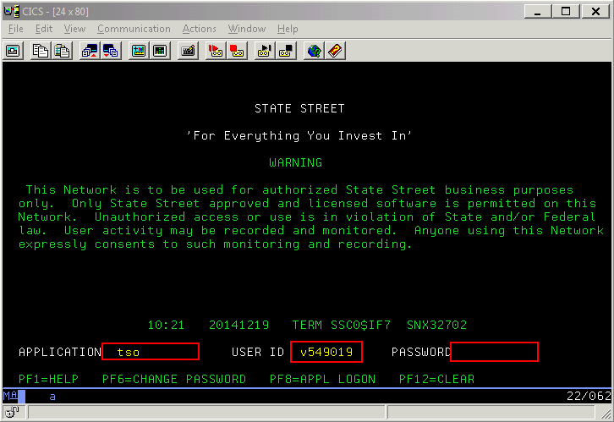

* 1. Next screen hit enter key

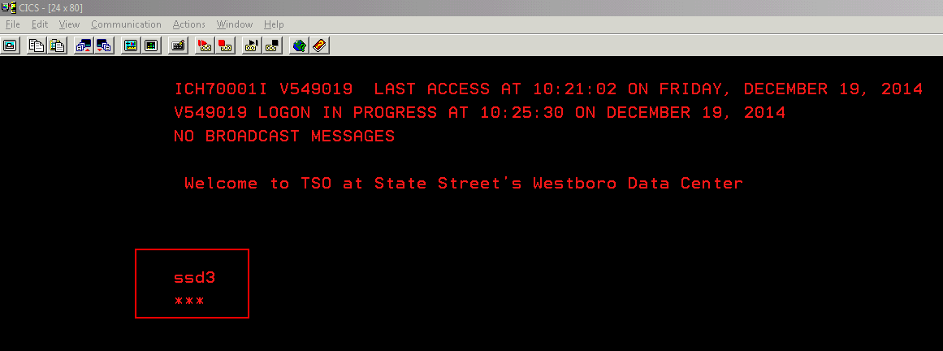

1. Select ISPF by typing ‘I’ and hit enter key

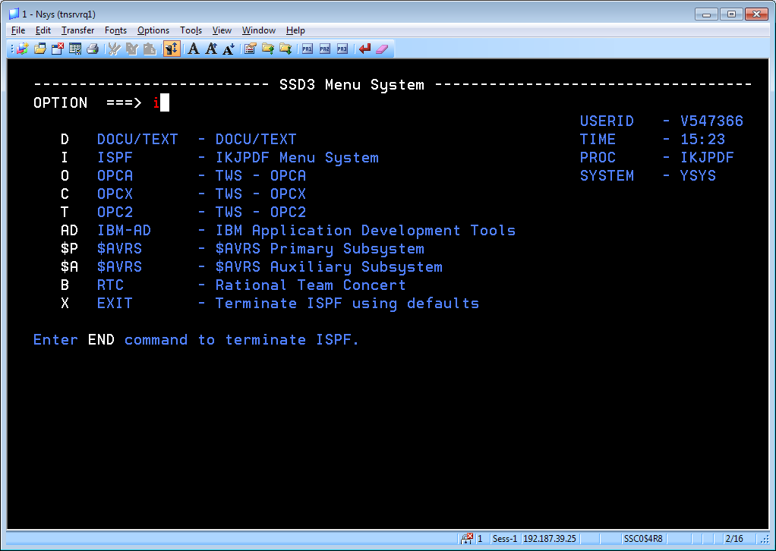

1. Select CHGMAN by typing ‘C’ and hit enter key

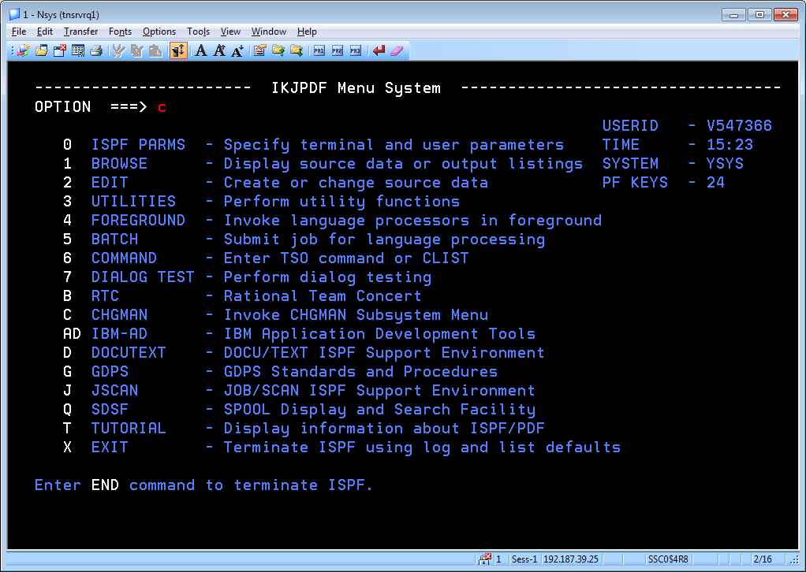

1. Select ATSMAIN menu by tying ‘4’ and press enter key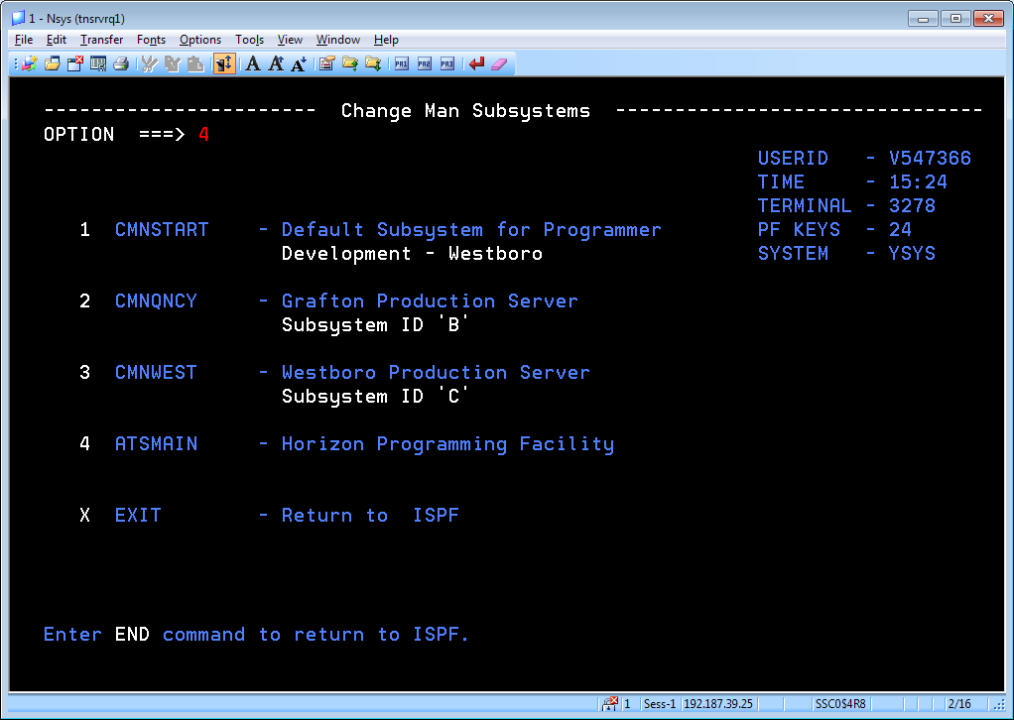
2. Select “SES Librerian Utility by selecting ‘1’ and hit enter key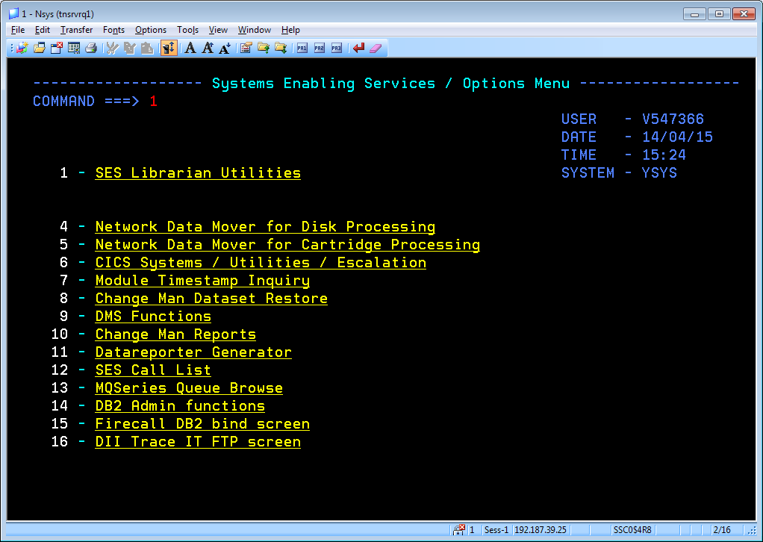
3. Select ‘5’ and hit enter kay to open “Application release Management” screen. 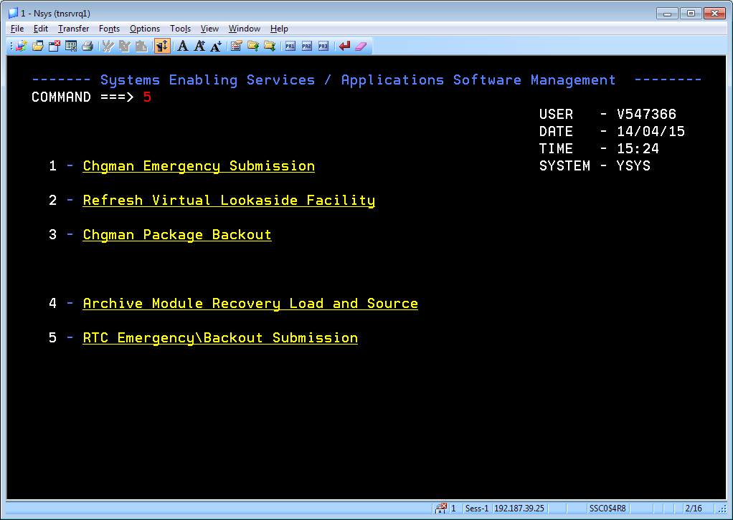
4. In Application Release Management Screen type the required application. By default application name is “HOZN” and enter the Work iteam and hit enter key to copy the member from the innstall libeary into production. (There is no other changes required in this screen.) 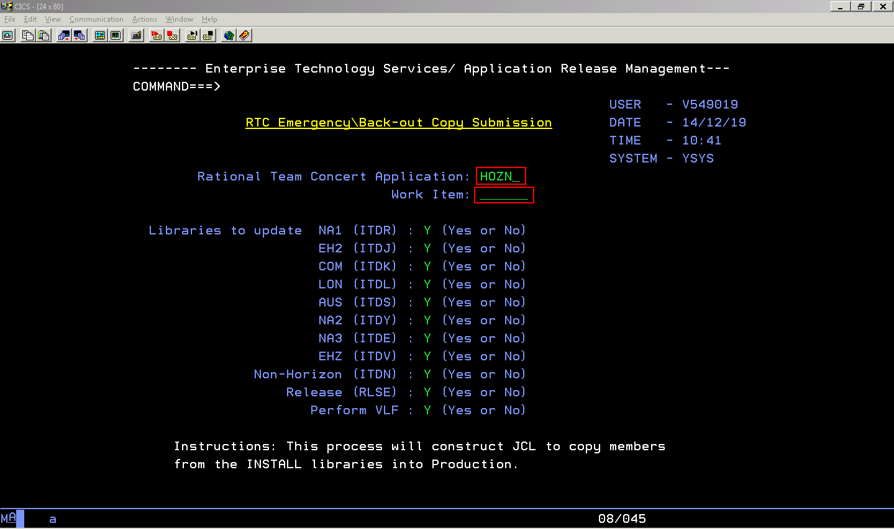
5. Press F3 key to move to previous screen. Press F3 until you get IKJPDF Screen. In IKJPDF Screen type ‘q’ to select SDSF menu and hit enter key. You should go to SDFF screen to verify the deployment status. 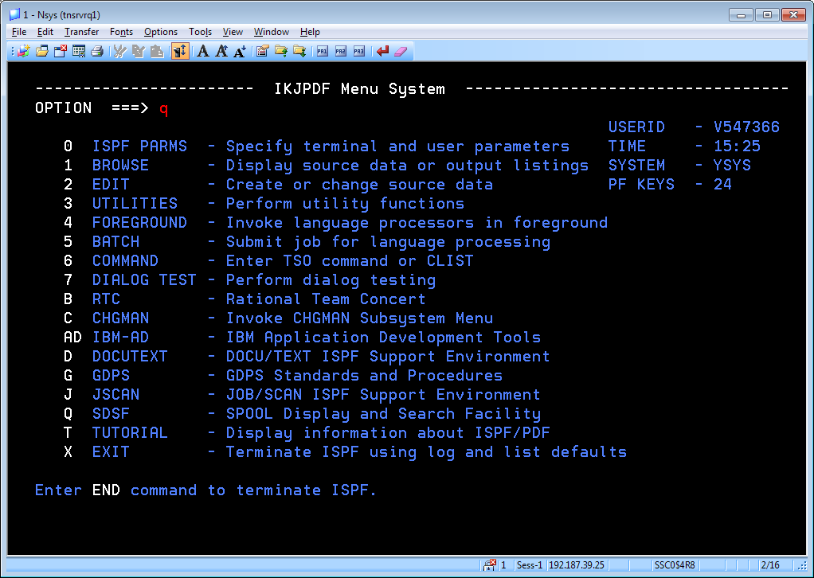
6. Type ‘st’ to select the status job menu and hit enter key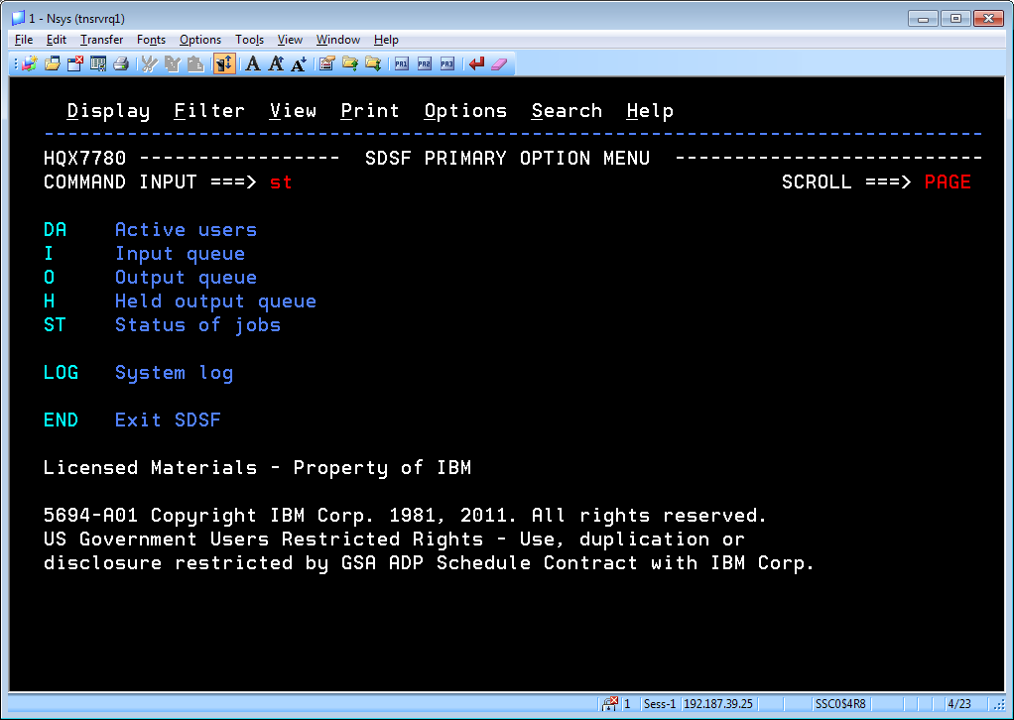
7. Type ‘**PRE C4HOZN\***’ to display the job name starts with ‘C4’. Then type ‘bottom’ in command line input to go to bottom of the page and look for the last two numbers of the work item.

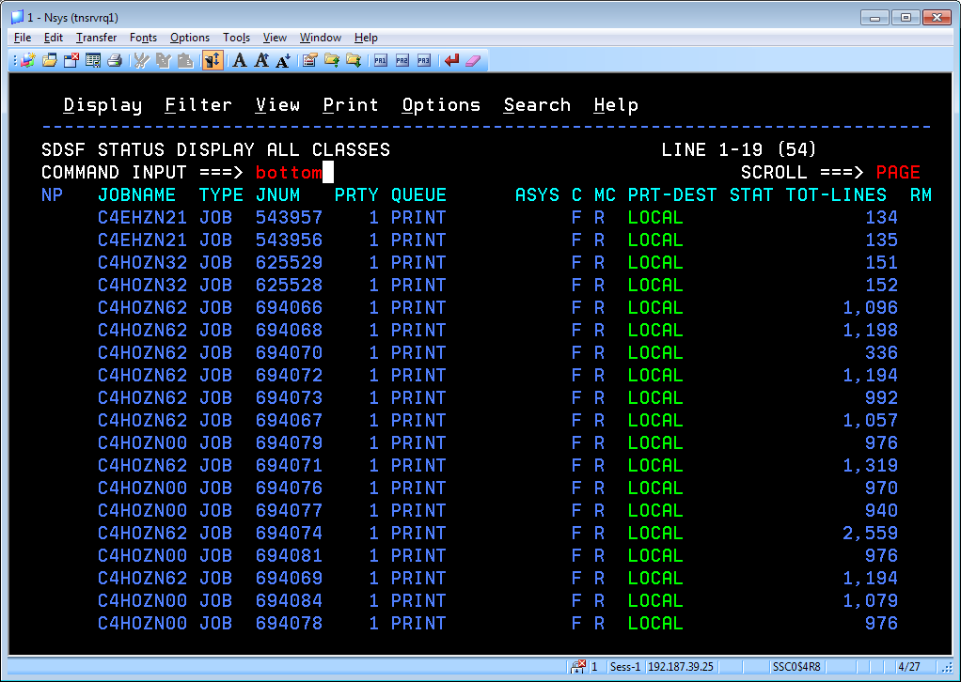

1. At the bottom of the page you can see the CR which you copied. The last 2 digit of the job name is same as last 2 digit of you Work item code.
   1. Here 1st 2 digit C4 is common for all
   2. Next 4 digit represent the Application
   3. And last 2 digit is last 2 digit of the work item which you copied into production.

Select the last 2 line by typing ‘s’ in the beginning of the line and hit enter key. You can see the SDSF output for selected job.

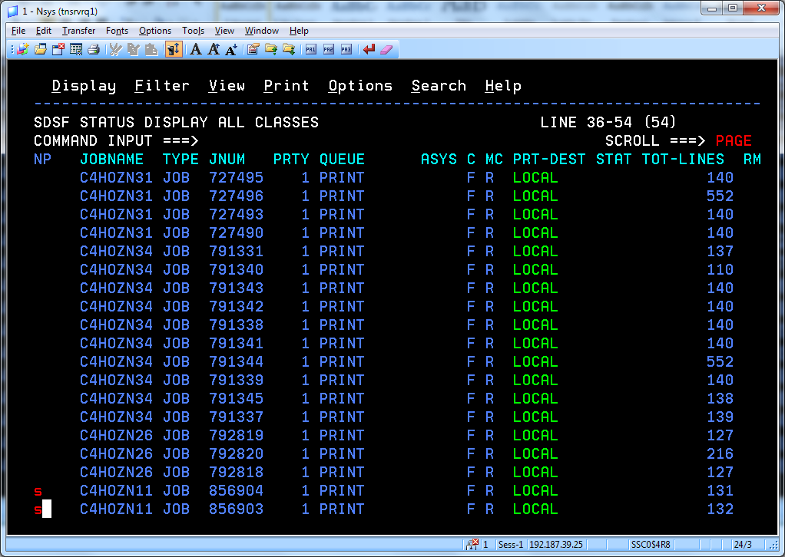

1. In SDF screen Return Code (RC) should be lower than 4. If the RC value in 4 or greater than 4 you need to contact Betty-Ann (BSmith@StateStreet.com) or Edward L Weare ([ELWeare@StateStreet.com](mailto:ELWeare@StateStreet.com)).

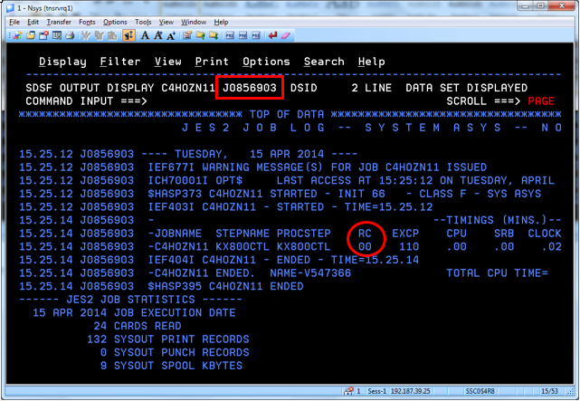

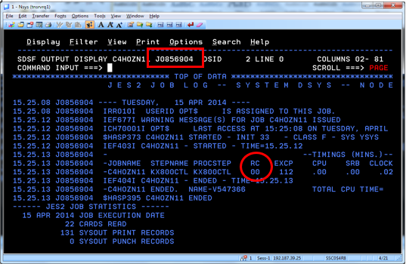

1. PF3 until you get to this screen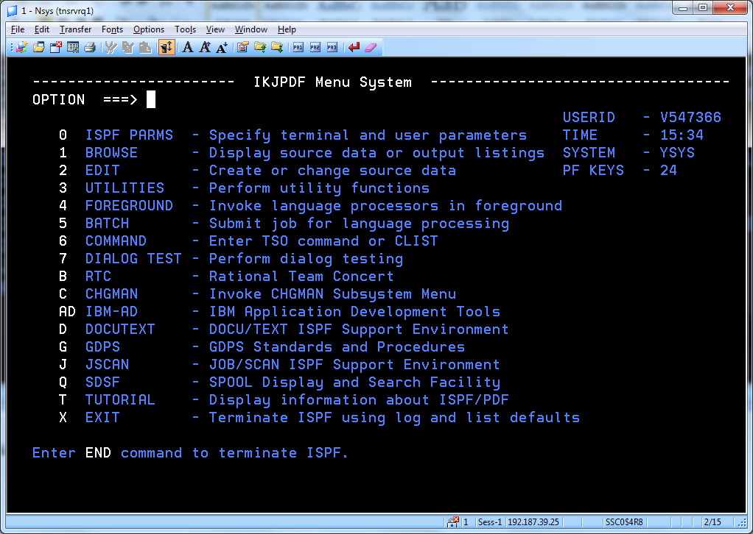
2. Type ‘x’ to exit from the window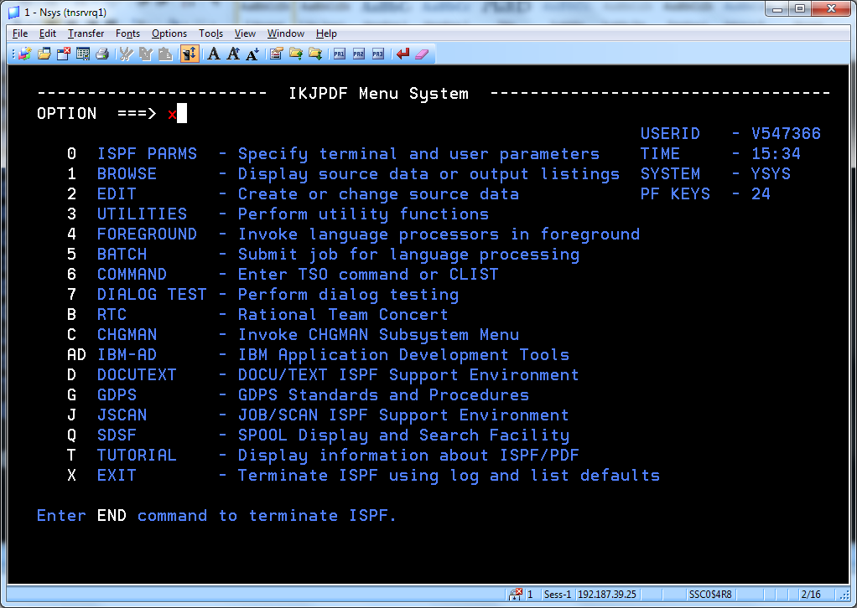
3. Type ‘x’ again to exit

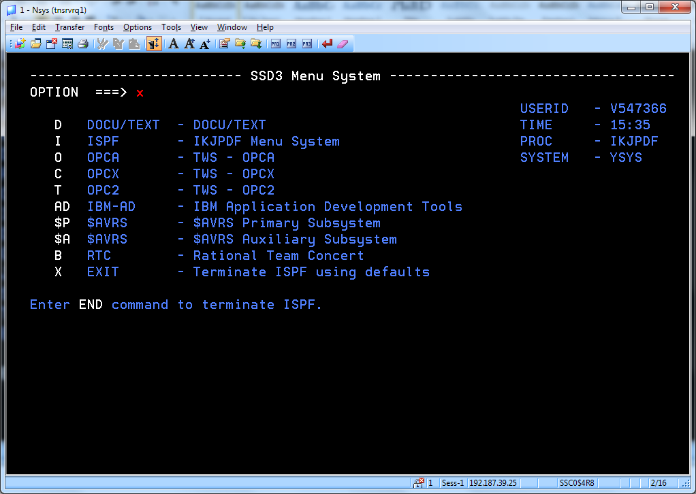

1. Type ‘logoff’ and hit enter Key to come out from Mainframe screen. 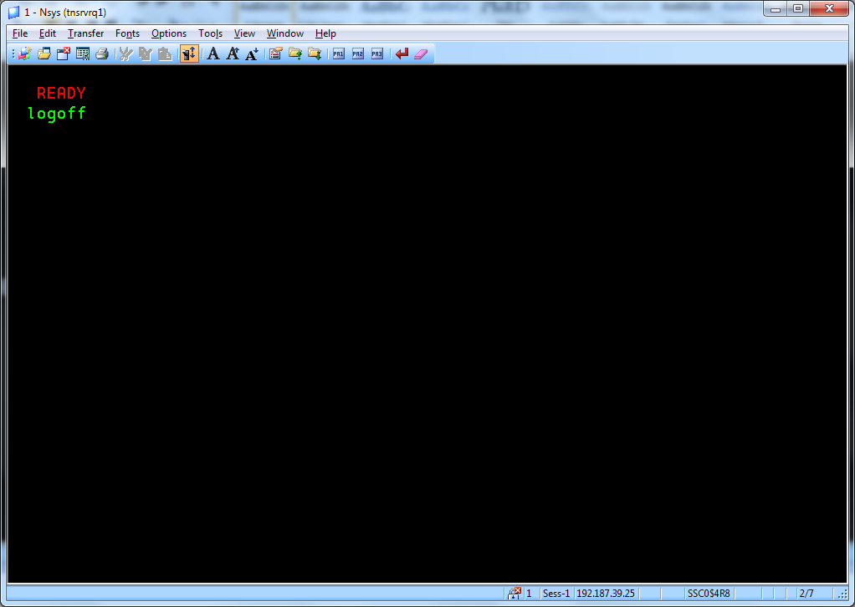

**~~~~~~~~~~~~~~~~~~~~~~~~~~~~~~END~~~~~~~~~~~~~~~~~~~~~~~~~~~~~~**